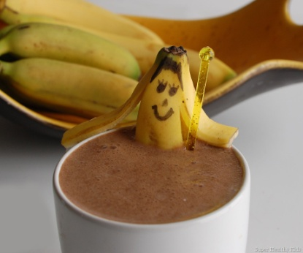
Chocolate Banana Smoothie
Ingredients:
1 cup chocolate milk
1 banana
1/3 cup vanilla yogurt
2 teaspoons honey
6 ice cubes

Directions:
- Measure all ingredients (except ice), and put it in the blender.
- Put the lid on the blender, and add ice a little at a time – blend.
- Pour into cups and enjoy!

